**Assessing Performance**

13 questions

1. If the features of Model 1 are a strict subset of those in Model 2, the TRAINING error of the two models can **never** be the same.

True

**False**

2. If the features of Model 1 are a strict subset of those in Model 2, which model will USUALLY have lowest TRAINING error?

Model 1

**Model 2**

It's impossible to tell with only this information

3. If the features of Model 1 are a strict subset of those in Model 2. which model will USUALLY have lowest TEST error?

Model 1

Model 2

**It's impossible to tell with only this information**

4. If the features of Model 1 are a strict subset of those in Model 2, which model will USUALLY have lower BIAS?

Model 1  
**Model 2**It's impossible to tell with only this information

5. Which of the following plots of model complexity vs. RSS is most likely from TRAINING data (for a fixed data set)? **c**

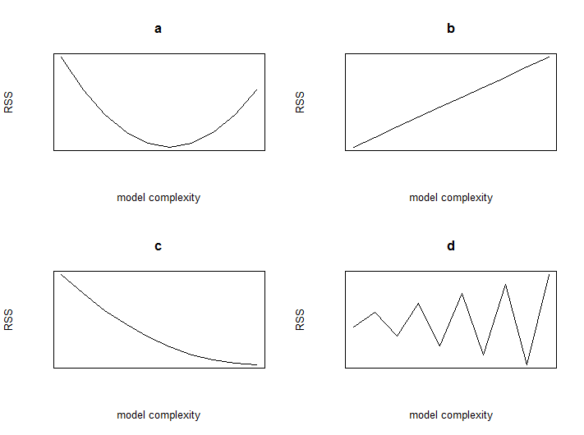

6. Which of the following plots of model complexity vs. RSS is most likely from TEST data (for a fixed data set)? **d (wrong) a (correct)**



7. It is **always** optimal to add more features to a regression model.

True

**False**

8. A simple model with few parameters is most likely to suffer from:

**High Bias**

High Variance

9. A complex model with many parameters is most likely to suffer from:

High Bias

**High Variance**

10. A model with many parameters that fits training data very well but does poorly on test data is considered to be

accurate

biased

**overfitted**

poorly estimated

11. A common process for selecting a parameter like the optimal polynomial degree is:

Bootstrapping  
Model estimation  
Multiple regression  
Minimizing test error  
**Minimizing validation error**

12. Selecting model complexity on test data (choose all that apply):

Allows you to avoid issues of overfitting to training data  
**Provides an overly optimistic assessment of performance of the resulting model**Is computationally inefficient (don’t think too much on this concept)  
**Should never be done**

1st trial: b,c wrong  
2nd trial: a,b wrong

13. Which of the following statements is true (select all that apply): For a **fixed model complexity**, in the limit of an infinite amount of training data,

The noise goes to 0  
Bias goes to 0   
**Variance goes to 0**Training error goes to 0   
Generalization error goes to 0